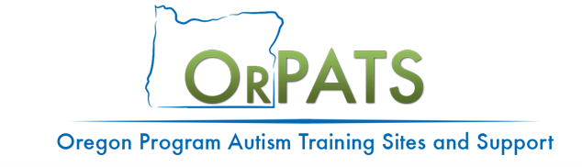
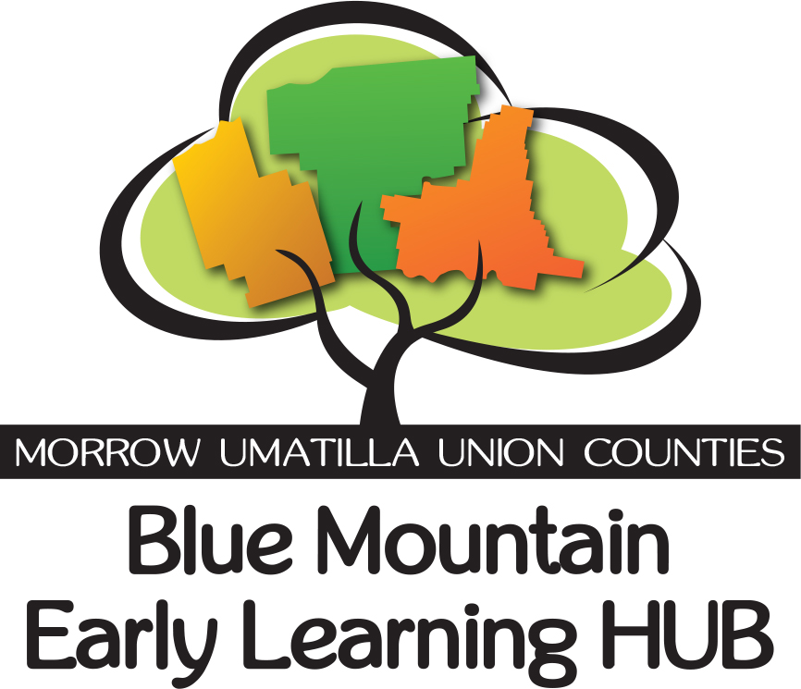



Supporting Children with Autism and Other Developmental Delays in Early Childhood Education Settings

Presented by Wynter Franzke and Alicia Balfrey, Oregon Program Autism Training Sites & Support Staff

This training opportunity will provide early childhood educators with a greater understanding of working with children with autism spectrum disorders. Topics discussed will include learning characteristics, behavioral strategies and simple activities to encourage social and language skill development. This workshop will provide specific examples of evidence-based practices that can be used immediately in the early education setting. This workshop is offered for free.
Who Should Attend:
Child care providers including Certified Center, Certified Family and Registered Family providers and program staff, Head Start staff, teachers, assistants and other staff providing services to children with Autism Spectrum Disorders.
What You Will Learn:
- The characteristics of children with autism
- Evidence-based strategies for working with children with autism and other developmental delays
- Practical instructional supports to improve social and language skill development
- Activities, behavioral supports and visual supports that can be used to immediately support children within the early education setting.
What You Will Receive:
- Examples of visual supports, behavior supports and social supports
- Access to additional on-line training modules
- Certificate of participation: Certificates will be for 6 hours of Set 1, Special Needs training, focused on birth-5 years old and accepted by ORO.

Where: Inter-Mountain ESD 2001 SW Nye Ave. Pendleton, OR 97801

When: Saturday, March 9, 2019 8:30 am -3:30 pm (1-hour lunch on your own)

Register at the following link: https://cascadetech.wildapricot.org/event-3276578
This workshop is at no charge to the participants or the childcare program.
Workshop will be presented in English but Spanish handouts will be available.

For registration questions or workshop questions please contact Brenda Hancock at bhancock@nwresd.k12.or.us

Persons with disabilities or who are in need of additional accommodations in order to attend should
contact Kathi Dehm at kathi.dehm@starautismsupport.com.

