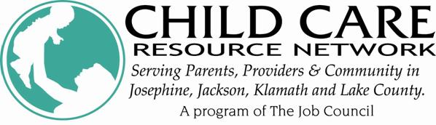
FREE Training

Western Oregon University’s QRIS Specialists present

Oregon’s Quality Rating and Improvement System (QRIS)
Exploring the QRIS Curriculum Standard

Presenters: Amber Ryerson and Cori Brownell, Western Oregon University

Where: Medford
RCC/SOU Higher Education Center
101 S. Bartlett Street
(corner of 8th and Bartlett)

When: Wednesday ~ May 14, 2014

Time: 6:00 pm to 9:00 pm

Register: Contact CCRN to register – ChildCareResourceNetwork@JobCouncil.org
or 541-842-2610

Cost: FREE

CKC: Learning Environments and Curriculum; 3 Hours; Set One

This session will:

- Discuss the importance of curriculum as an essential component of a quality early learning and development program

- Review the QRIS standards relating to curriculum

- Give information on the approved QRIS curricula and why they were selected

- Provide information and assistance to determine if other curricula meet QRIS standards, including curricula developed by individual programs

We hope to see you there!

Q u a l i t y C h i l d C a r e L a s t s A L i f e t i m e

