Sponsored by:
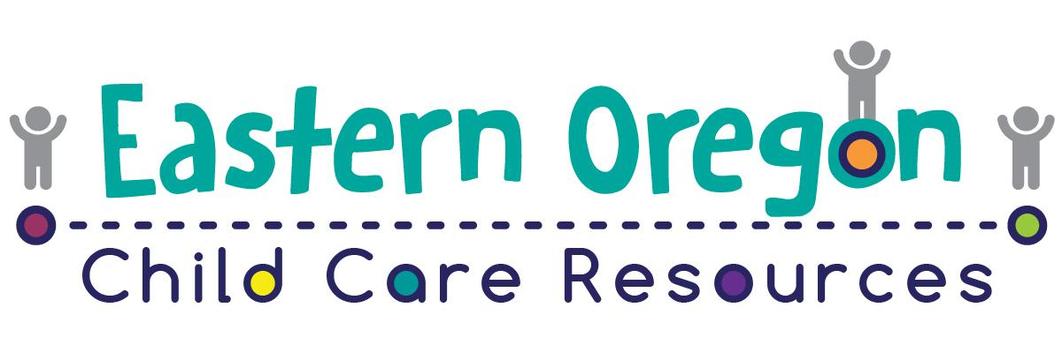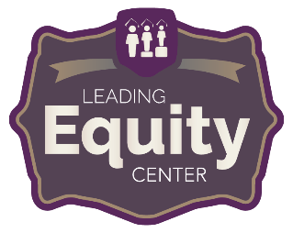  Equity training Series  - Feb. 12th-How to Be an Antiracist  - Feb. 19th- Antiracism/Antibias Practices  - Feb. 26th- Framing Brave Conversations About Race and Ethnicity  - Mar. 5th- The Dangers of Performative Wokeness  - Mar. 12th- Do Black Lives Matter?  - Apr. 2nd- Multicultural Education in Predominantly White Spaces  - Apr. 9th- Teaching Privilege and Power to Students  - Apr. 16th- Cultural Appropriation Vs. Cultural Appreciation  - Apr. 23rd- Addressing Racial Slurs in School and Curriculum  - Apr. 30th- Raising Big Voice in Little People- Raising Cultural Self-Esteem and Advocacy in Young Children  - May 7th- Cultivating Family Leadership- Empowering Families to Lead an Anti-Racist Education  - May 14th- Restoring Family Culture- Examining Strategies to Support Families in Reviving Their Cultural Traditions  - May 21st- Home Grown Advocacy- Empowering Families to Challenge Schools to See Beyond Race, Ethnicity and Class  - May 28th- Equity during Remote Learning for Families- A closer look at addressing the disproportionate impact on remote learning for essential workers.  Meet our Presenters!  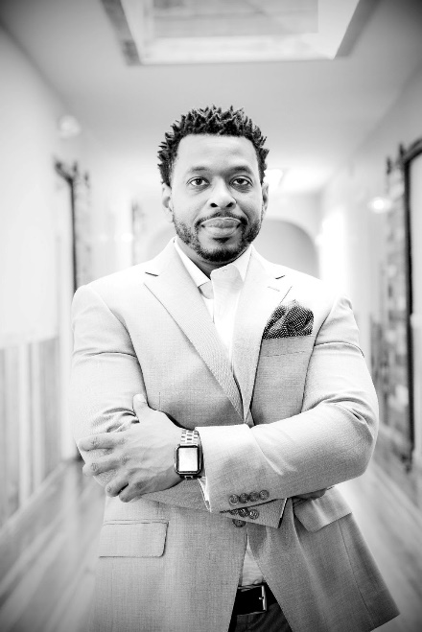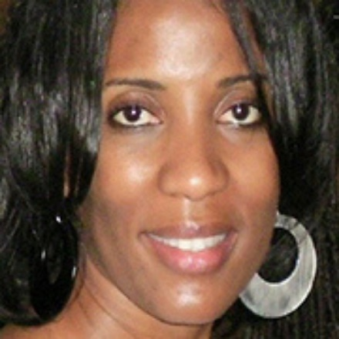  Dr. Sheldon L. Eakins is the founder of the Leading Equity Center and Host of the Leading Equity Podcast.  Dr. LaWanda Wesley serves as Oakland Unified School District's Director of Quality Enhancement and Professional Development of Early Education. | Each training has two time slots available:  8:00 - 9:00 am PST  OR  6:00 - 7:00 pm PST  ────  A total of 14 trainings (14 Set 1 hours in the CKC Diversity)  ────  Questions contact:  Eastern Oregon Child Care Resources  Dione Ashby, Infant/Toddler Specialist- 458-214-0536  dione.ashby@malesd.org  or  Chalene Harshman, Quality Improvement Specialist- 458-214-0497  chalene.harshman@malesd.org
Training Links

FEb 12th
- Am: https://forms.gle/uLD3hvgZnfJ8TLDUA
- PM: https://forms.gle/Qq3dkX3noz5hXrMk8

Feb 19th
- Am: https://forms.gle/DjyWD6pGydzerspx7
- PM: https://forms.gle/6VqVmez8da8t1bKY8

Feb 26th
- am: https://forms.gle/gfUEXFLv9xkNUT4x6
- pm: https://forms.gle/h7ETGzzjAzuHn6JJ7

Mar 5th
- am: https://forms.gle/BygoPYoXdUQ67Djm9
- pm: https://forms.gle/SybC6joSabUXorqZA

mar 12th
- am: https://forms.gle/rbBXiLvNsaRd4AHE9
- pm: https://forms.gle/P3Au3PXSiHko3xdL9

Apr 2nd
- am: https://forms.gle/xhvCugh96wJuikTC8
- pm: https://forms.gle/jAwcWrv26mqgy2RBA

apr 9th
- am: https://forms.gle/HoYu6X1gbcbC4ZWY8
- pm: https://forms.gle/VFkwdGgAdGb1ETGP7

apr 16th
- am: https://forms.gle/uFM7KH9CS6TGdfHp7
- pm: https://forms.gle/MdCPizTqdiXFpcRy8

apr 23rd
- am: https://forms.gle/BHFyAmD6cuNEm1zt7
- pm: https://forms.gle/rDe2jW4ajcrtWHnA7

apr 30th
- am: https://forms.gle/Pm1bEggHpcy5TTw6A
- pm: https://forms.gle/NXX4VcoaoNN8Bs8M8

may 7th
- am: https://forms.gle/jhQLTCpf4ccYVhVv8
- pm: https://forms.gle/qRzGNvwAbG1FZk7w5

may 14th
- am: https://forms.gle/8JxE3hjcSp1FBMjB9
- pm: https://forms.gle/Q6ZLWaLf25M5reC76

may 21st
- am: https://forms.gle/mSjnfELgpNQiT1sw7
- pm: https://forms.gle/m2PU6pXTzzTMPEXs8

May 28th
- AM: https://forms.gle/1Bh1g64WMeogeb6z9
- pm: https://forms.gle/76sTK8hAUKZvFRYb6

